

December 11, 2025

The 2025 M&A Environment

Headliner deals in 2025 continued the trend of blockbuster acquisitions in the US insurance distribution system. Arthur J. Gallagher acquired Woodruff Sawyer in April. Brown & Brown acquired Accession (Risk Strategies / 180 Intermediaries) in August. IOA received a majority investment from MDP and Navacord in November. The Baldwin Group announced an acquisition of CAC Group that is expected to close in 2026. Also announced in December, Willis Tower Watson’s acquisition of Newfront is expected to close in Q1 2026. All of these deals had enterprise values over $1 billion, with the Accession deal approaching $10 billion.

These announcements, though, aren’t the only story of insurance broker M&A in 2025. The other story is about the reported decline in overall deal volume. Through November 2025, announced deals were down over 25% from 2024, according to S&P Market Intelligence. In fact, only 385 deals had been announced through November, making it the lowest year-to-date total since 2014. With data like this, are we at a point where consolidation is slowing? Is the frenzied pace of broker M&A finally calming down?

2025 Broker M&A: High profile deals continue while overall volume declines

Large Deals Made Headlines in 2025 …

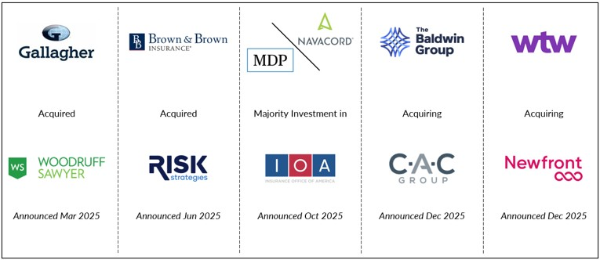

… while Total Announced Deals are the Lowest Since 2014

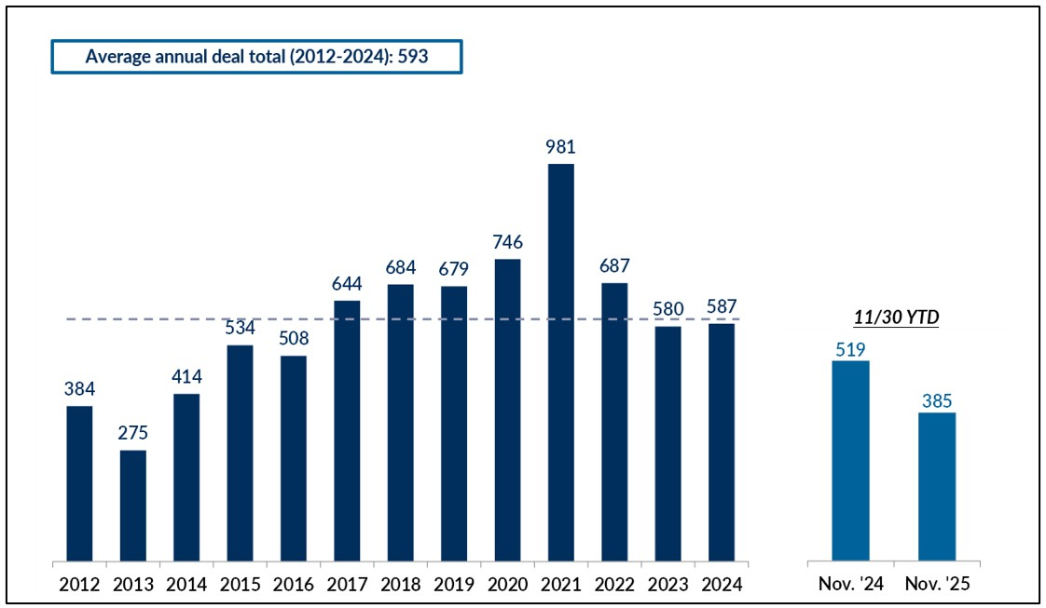

Source: Press releases, S&P Market Intelligence

The answer is yes and no, as several factors are driving the trends in announced deals.

- Deal announcements are out of fashion. Buyers have different philosophies on publicizing transactions. For many acquirors, doing deals is still a priority, but announcing those deals is not. Whether for competitive reasons or for a desire to stay under the radar, several high-volume buyers have opted out of M&A press releases. This phenomenon understates the actual M&A activity in our industry. And while the announced deals have always represented a percentage of total deal volume, we believe that percentage is decreasing.
- The supply side of the deal equation isn’t quite what it used to be. Any market requires supply and demand, but the consistently high level of M&A activity has thinned out the supply side of the insurance distribution M&A market. This is especially true of the most attractive segment of the market for many buyers – firms over $10 million in revenue. These firms are highly sought after for the scale and talent they bring to buyers – they can be platforms in a new geography or specialization. However, many of these firms have been acquired over the last five years and the next generation of $10 million + firms is under construction. Without the supply of the most attractive set of firms, overall market activity has slowed.
- The demand side also has some challenges. Compared to any period prior to ten years ago, the demand side of the equation is still incredibly strong. However, we believe demand has ebbed slightly from its peak 4-5 years ago. The cooling in demand has been caused by two main factors. First, some of the large acquirors have been taken out of the market because they themselves have been acquired. Assured Partners and Accession, especially, were high volume buyers that are now consolidated within Gallagher and Brown & Brown. Second, investors have increasingly encouraged management teams to focus on integration and de-leveraging instead of revenue aggregation, shifting attention away from M&A. We’re still firmly in a sellers’ market, but it isn’t quite as dramatic as it was in 2021.

So even though the slowing in deal activity may be slightly overstated due to the decline in public announcements, the number of M&A transactions is down. However, because the primary driver is reduced supply, valuations are holding. We are seeing a marginally greater spread of multiples between high and low-quality firms in the same size category, but overall multiples are consistent with what we’ve seen over the past several years.

We are not predicting any major changes to the pace of consolidation – or to valuations – in 2026. A few interest rate cuts could boost activity and valuations, but public broker stock performance – down on average over 25% from their early 2025 highs - could have the opposite effect. Most importantly, though, the insurance distribution system remains a fragmented industry in which there are clear benefits of scale. Continued consolidation is a natural consequence of that environment.

  
  Brian Deitz
  President, Reagan Consulting
   | 

ReaganView is Reagan Consulting’s forum for providing an occasional perspective on issues and opportunities relevant to the insurance distribution industry.



 |  |  |  | 

*This document includes only general information and should not be relied upon as legal, tax or compliance advice.
Copyright © 2025 Reagan Consulting, All rights reserved.
Subscribers of Reagan Consulting
Want to subscribe to our emails? Click here. Already subscribed and want to update your email preferences? Click here.

